**Open Interconnect Consortium (OIC)**

**Open Interconnect Consortium (OIC) overview:**

* The OIC (Open Interconnect Consortium) is a non-profit organization founded by leading tech companies to define the connectivity and interoperability requirements for the billions of devices that will make up the Internet of Things (IoT).
* It is a consortium founded by Intel, Dell, Samsung and Broadcom among others to promote standards for the development of the IoT.
* Its stated goal is "defining a common communications framework based on industry standard technologies to wirelessly connect and intelligently manage the flow of information among personal computing and emerging IoT devices, regardless of form factor, OS, or service provider."
* The OIC has developed a set of open specifications and a reference implementation called IoTivity to enable seamless device-to-device connectivity across a variety of IoT devices and platforms.
* In early 2015, the OIC released a specification called IoTivity, an open-source framework implementing the OIC Standards for device-to-device connectivity.

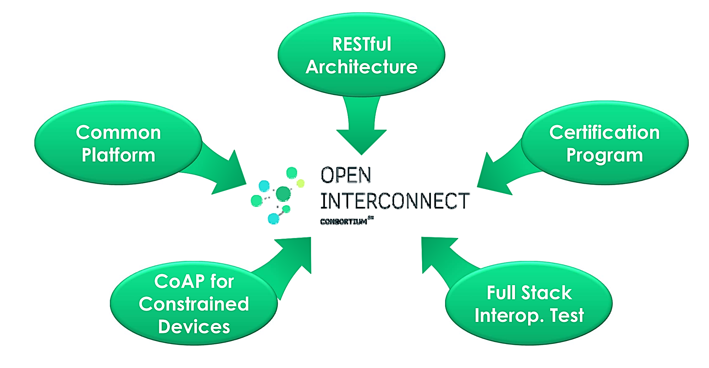

**OIC design principles:** The OIC is an organization that aims to create standards for the IoT and ensure interoperability among IoT devices. Its design principles focus on enabling seamless communication and cooperation among diverse devices and platforms. The OIC's design principles have played a major role in the development of the IoT ecosystem. By making IoT devices more interoperable, scalable, and secure, the OIC has helped to accelerate the adoption of IoT technologies by businesses and consumers. Here are the key design principles of OIC:

* **Interoperability:** OIC is built on the core principle of interoperability. It strives to create a common framework that allows different IoT devices, regardless of their manufacturer or underlying technology, to communicate and work together effectively. Interoperability is essential for avoiding siloed ecosystems and fostering the growth of the IoT.
* **Open Source:** OIC adopts an open-source approach. The source code, software libraries, and standards developed by OIC are freely available and accessible to developers and organizations. This open-source philosophy encourages collaboration, innovation, and transparency in the IoT ecosystem.
* **Industry Collaboration:** OIC emphasizes collaboration among industry leaders, stakeholders, and technology experts. It seeks to create a unified IoT standard by bringing together organizations from various sectors, including consumer electronics, industrial automation, healthcare, and more.
* **Standardization:** OIC's design principles promote the establishment of standard protocols and specifications for IoT devices and services. These standards ensure that devices can communicate seamlessly, reducing the complexity of developing and managing IoT solutions.
* **Security and Privacy:** Security and privacy are fundamental design principles within OIC. IoT devices often handle sensitive data, and the consortium places a strong emphasis on ensuring that data is protected during transmission and storage. Robust authentication, encryption, and access control mechanisms are integrated into OIC's standards.
* **Resource-Oriented Approach:** OIC follows a resource-oriented approach to IoT device communication. In this model, everything is represented as resources, each identified by a unique URI. Standard methods (GET, PUT, POST, DELETE) are used to interact with these resources. This resource-based architecture simplifies device communication and management.
* **Cross-Domain Compatibility:** OIC recognizes that IoT devices span a multitude of application domains, from smart homes to industrial automation. Its design principles accommodate the varying requirements of these domains, ensuring cross-domain compatibility and versatility.
* **Scalability:** OIC's design is scalable, making it suitable for both small-scale IoT deployments, such as individual smart homes, and large-scale, enterprise-level implementations, like smart cities or industrial IoT networks.
* **Lightweight:** OIC protocols and implementations should be lightweight and efficient, so that they can be used on a wide range of devices, including resource-constrained devices.
* **Extensible:** OIC should be extensible to support new features and requirements. This is achieved by using a modular architecture and open APIs.
* **Plug and Play:** OIC simplifies device integration through plug-and-play interoperability. Devices can be seamlessly connected to a network, and their capabilities are automatically discovered and exposed. This ease of integration enhances the user experience and encourages wider adoption of IoT solutions.
* **Device Management:** OIC supports comprehensive device management, enabling device lifecycle management, software updates, and remote configuration. This design principle simplifies the maintenance and operation of IoT devices.
* **Cross-Platform Support:** OIC provides software development kits (SDKs) and APIs for different platforms, including Linux, Android, and Windows. This cross-platform support ensures that developers can create applications that run on various operating systems and hardware.
* **Community-Driven Development:** OIC fosters a vibrant community of developers and contributors who work together to improve and expand the consortium's standards and technologies. This community-driven development approach ensures ongoing refinement and development of IoT standards.

The OIC's design principles are reflected in its specifications and implementations. For example, the OIC Core Specification defines a common resource model and set of protocols for device discovery, resource management, and data exchange. The OIC IoTivity open-source implementation provides a complete framework for developing and deploying OIC-compliant devices and applications.

The OIC's design principles have been widely adopted by the IoT industry. Many leading IoT device manufacturers and software vendors are members of the OIC and are developing products and solutions that support the OIC specifications.

Here are some examples of how the OIC's design principles are being used in practice:

* **Interoperability:**OIC devices are being used in a variety of smart home ecosystems, where devices from different manufacturers can interoperate with each other and with a central hub.
* **Scalability:**OIC devices are being used in large-scale industrial IoT applications, where millions of sensors and machines are connected to the cloud for data collection and analysis.
* **Security:**OIC devices are being used in critical infrastructure applications, such as smart grids and transportation systems, where security is a top priority.

**OIC Features:** The OIC open-source architecture is based on a number of key features, including:

* Openness: The OIC specifications are open and publicly available, and anyone can implement them. This helps to promote innovation and competition in the IoT market.
* Interoperability: The OIC specifications are designed to ensure interoperability between IoT devices from different manufacturers. This allows users to mix and match devices to create custom IoT solutions.
* Scalability: The OIC architecture is designed to be scalable to support billions of IoT devices.
* Security: The OIC architecture includes a number of security features to protect IoT devices from unauthorized access and attack.

**OIC Components:** The OIC open-source architecture is a modular architecture that consists of the following components:

* Information model: The information model defines a common way to represent and exchange data between IoT devices.
* Resource model: The resource model defines a common way to model and interact with IoT devices.
* Connectivity layer: The connectivity layer provides a common way for IoT devices to connect to each other and to the cloud.
* Discovery and onboarding layer: The discovery and onboarding layer provides a way for IoT devices to discover each other and to join an IoT network.
* Security layer: The security layer provides several security features to protect IoT devices from unauthorized access and attack.

**OIC Advantages:** The OIC open-source architecture offers many benefits for IoT developers and users, including:

* Reduced development costs and time-to-market: IoT developers can use the OIC specifications and reference implementation to quickly and easily develop interoperable IoT devices and applications.
* Increased flexibility and choice: IoT users can choose from a wide range of OIC-compliant IoT devices and applications.
* Reduced vendor lock-in: The OIC open-source architecture helps to reduce vendor lock-in by enabling users to mix and match devices from different manufacturers.
* Enhanced security: The OIC architecture includes a few security features to protect IoT devices from unauthorized access and attack.

**OIC Architecture:**

* OIC adopted RESTful Architecture: Things modeled as resources.
* Current OIC Architecture defines 2 logical roles that devices can take.
  + OIC Server: A logical entity that exposes hosted resources.
    - i) host OIC Resource & ii) send a response & provide service
  + OIC Client: A logical entity that accesses resources on an OIC Server
    - i) Initiate a transaction (send a request) & ii) access an OIC Server to get a service
  + Intermediary role: Bridges messaging between client and server

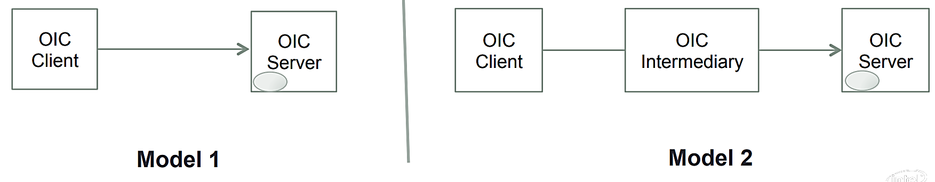

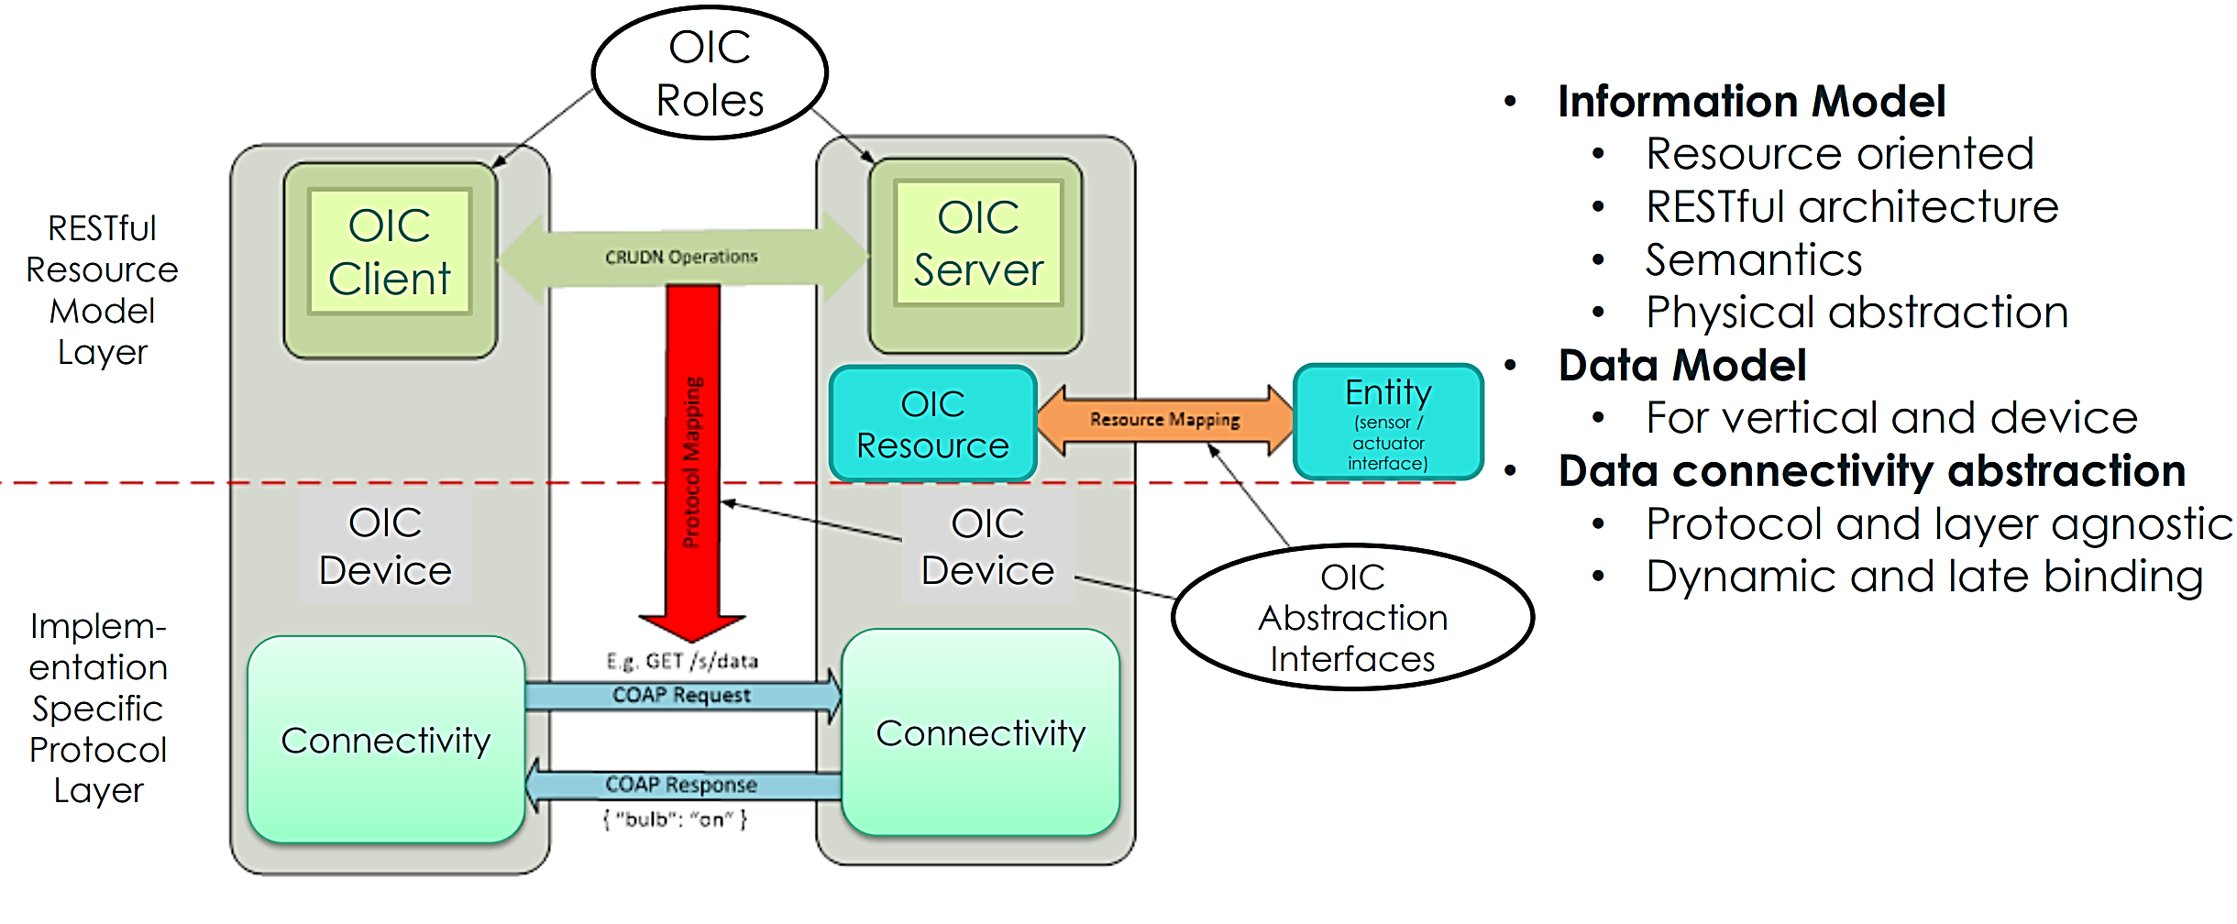

**OIC Applications:** The OIC open-source architecture is a leading open-source architecture for the IoT. It is supported by a broad range of companies, including Intel, Samsung, LG, and Qualcomm. The OIC architecture is being used in a wide range of IoT applications, including smart home, smart city, and industrial IoT.

Here are some examples of how the OIC open-source architecture is being used in the real world:

* Smart home: The OIC architecture is being used to develop smart home devices that can interoperate with each other to create a seamless and intelligent home environment. For example, an OIC-compliant smart light bulb can be controlled by an OIC-compliant smart thermostat to create an energy-efficient lighting system.
* Smart city: The OIC architecture is being used to develop smart city solutions that can improve the efficiency and sustainability of cities. For example, OIC-compliant traffic sensors can be used to monitor traffic flow and optimize traffic signals.
* Industrial IoT: The OIC architecture is being used to develop industrial IoT solutions that can improve the productivity and efficiency of industrial operations. For example, OIC-compliant industrial sensors can be used to monitor the condition of industrial equipment and predict maintenance needs.

